B58015
User manual
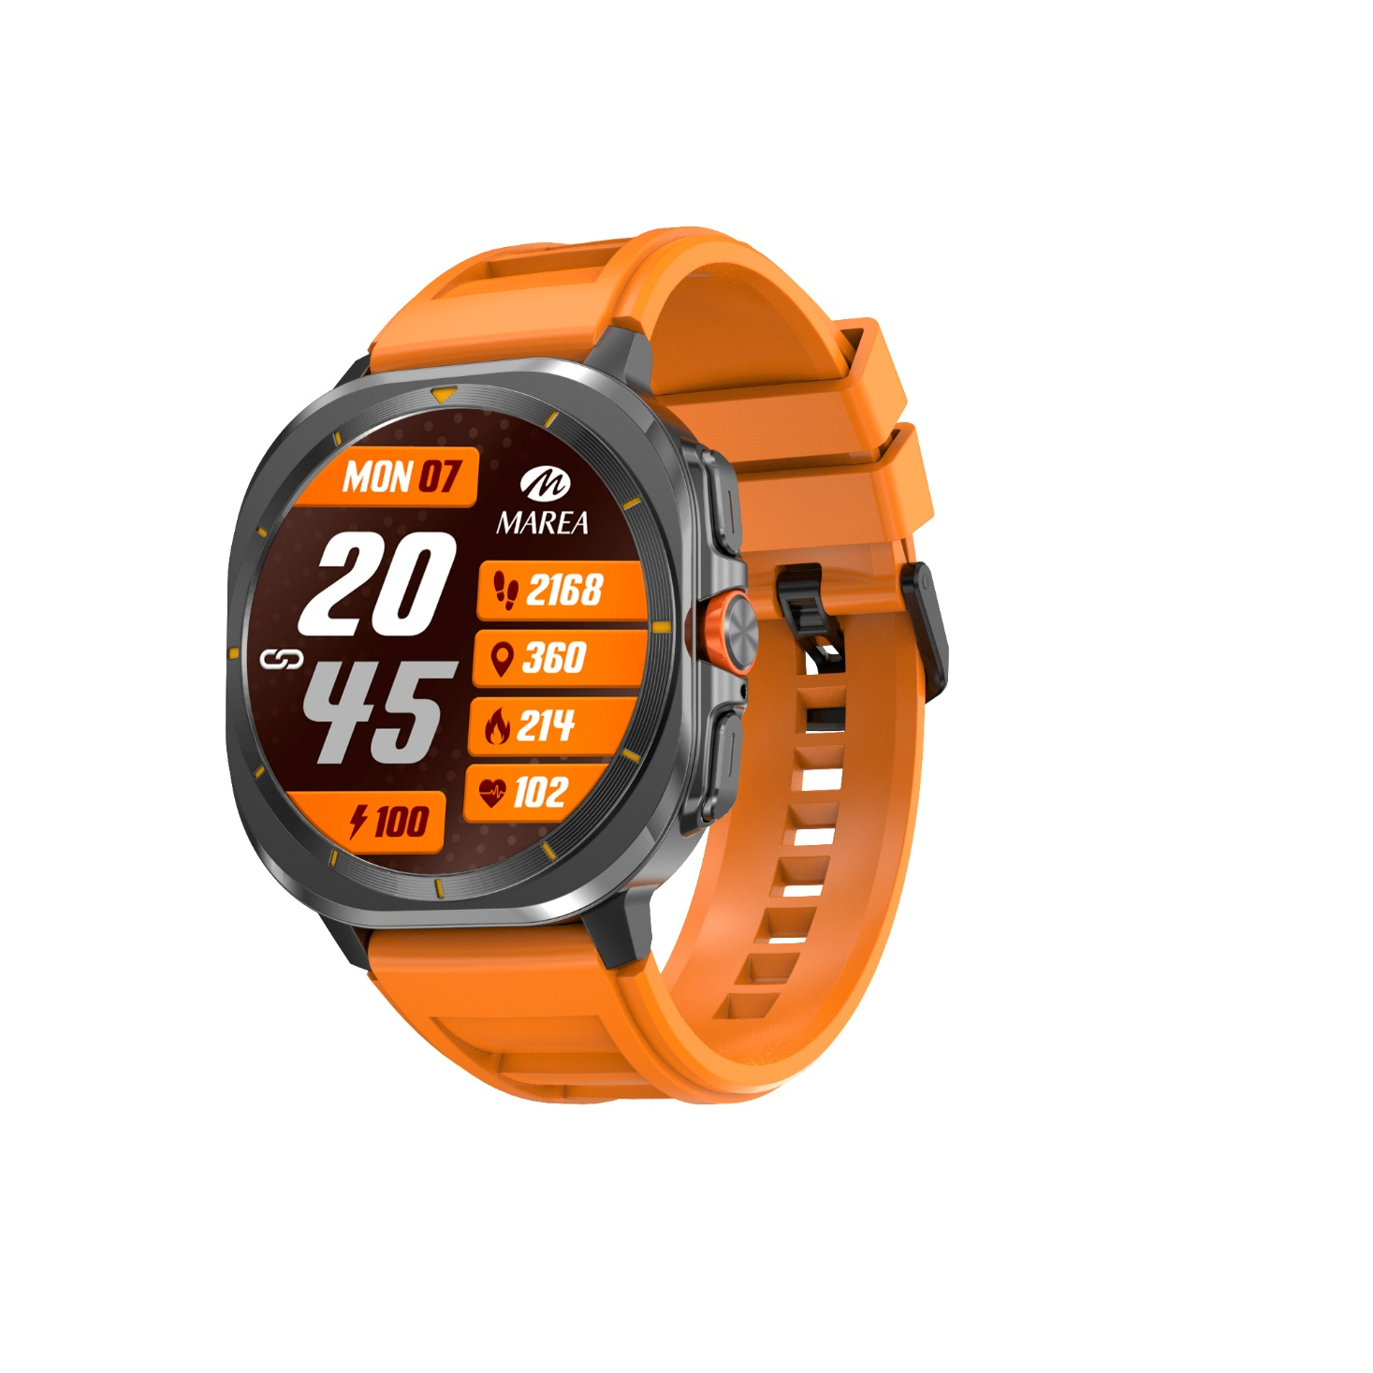
Please read this manual before using the product to fully understand its use and operation.
CAUTION
- The company reserves the right to modify the contents of this manual without any further notification. Some functions may vary in certain versions of software.
- Please charge this product with the charger provided for no less than 2 hours before using it for the first time.
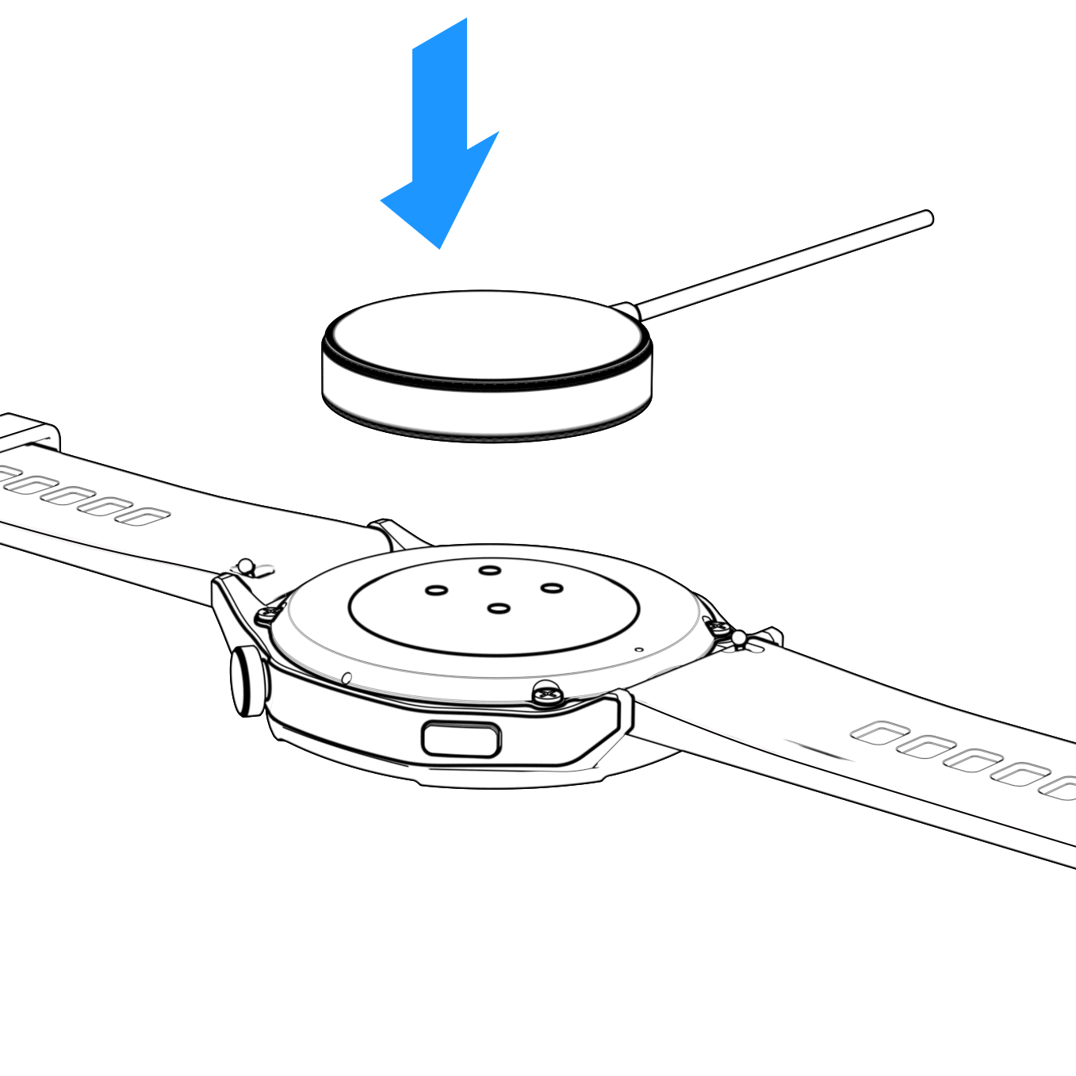
- Use only the charger that is included with the product. Make sure that the charger and the smartwatch are properly connected while charging. Do not charge if the watch has water (or sweat) to avoid short circuits and damaging the product.
- The two contacts of the charging cable cannot be in contact with a conductor material at the same time, it will cause a short circuit and burn.
- Do not expose your smartwatch to other liquids such as salt water, chlorinated water, and other liquids and chemicals.
- Do not expose your device to hot water or water vapors.
- Water and dust resistance is not permanent and may decrease as a result of regular use.
- Clean the smartwatch regularly, especially its inner side, and keep it dry. Skincare product should not be used on the wrist that wears the smartwatch.
- Don’t look steadily at the green light of the sensor on the back of the smartwatch, it may cause eye irritation.
System Requirements:
Android: Android 4.4 or above
iPhone: iOS 10.0 or above

Download and install the application
1. Go to our website www.mareasmart.com and find your smartwatch model. The model number is found on the back of the smartwatch (it starts with “B” and is followed by five digits).
2. Download and install on your phone the official app that corresponds with your smartwatch model.
3. Open the app and enable all the permissions that the app requests.
4. Turn on Bluetooth on your phone.
5. Make sure that the smartwatch has not been linked directly through Bluetooth to your phone. If so, unlink it.
6. Bind your Marea Smartwatch through the app.
Notes on linking:
- Only one smartwatch pairing application should be installed on the phone to ensure that the connection with the smartwatch is normal. If several applications are connected, they can affect the connection between the watch and the phone.
- Some Android phones will prompt you that they cannot install the app. Please go to ‘settings’ of the phone and authorize the ‘Unknown source’.
- When the mobile phone requests permissions, click "Allow". On the contrary, you may not receive notifications, scan QR codes, open the remote camera or use other functions. These permissions do not affect the flow of the phone or other information on the phone.
- Some Android phones may accidentally close the app when cleaning the applications. Please keep the app running in the background. To turn on this function on your phone: open the phone settings - application management - official application - rights management - backstage management - select background running. The setting method may be different due to different mobile phone versions and models.
- For iPhone: if the phone is in standby or hibernation mode for a long time (for example, the phone has not been in use for 2 hours or more and the screen is off), the application will be closed by the iOS system, so the application and the watch will be disconnected and the application functions will not be available. Re-activate the phone and it will automatically reconnect.

Smartwatch operation
Turn on/off
Press and hold the button for 3 seconds to turn on the smartwatch; short press the button to activate the watch when in standby mode.
Press and hold the button for 3 seconds to turn off the smartwatch.

Button and screen operation
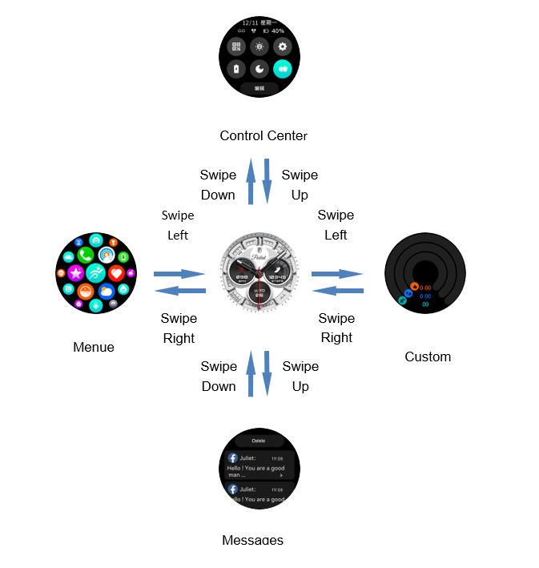
Return
From any function, swipe right or short press the button to return to the previous menu.

Home screen selection
Long press the home screen to enter the selection interface. Swipe left or right to see the different options.
On the app you can download other predesigned home screens as well as select an image saved on the phone to set as your home screen.

Main functions in Smartwatch
The main menu includes the following functions:

Call log / Contacts / Call function
You can make and receive Bluetooth calls from your smartwatch. From the app, you can select which contacts you want to import to the contact list on your smartwatch. The phone and the watch must be linked and within the Bluetooth range.

Activity
Shows the steps taken, the distance traveled and the calories consumed on the current day. On the app you can check the historical data.

Heart Rate
Upon entering the function, the heart rate measurement will start automatically. Wait about 30-60 seconds for the measurement to finish and the result will be displayed. On the app you can check the historical data.

Sports
Includes different sport modes.
Click on the corresponding exercise mode to begin the recording. Slide right to pause or end the exercise and save the data. On the app you can check the historical data.

Blood Oxygen
Upon entering the function, press play to start the blood oxygen measurement. Wait about 30-60 seconds for the measurement to finish and the result will be displayed. On the app you can check the historical data.

Blood Pressure
Upon entering the function, the blood pressure measurement will start automatically. Wait about 30-60 seconds for the measurement to finish and the result will be displayed. On the app you can check the historical data.

Sleep Monitor
If you have worn the watch during the previous night, it shows the total sleep time of last night, as well as light and deep sleep times. You can check the historical data on the app.

Notes on health functions:
- The heart rate, blood pressure, and blood oxygen functions require the watch and arm to be in contact, and the watch should not be too tight or too loose. The test can be inaccurate if it is too tight because it will affect blood flow, and if it is too loose because it will affect the monitoring of the heart rate sensor.
- Be sure that there the heart rate sensor on the back of the smartwatch is clean. Skin color, hair density,
tattoos and scars may affect the accuracy of the measuring results.
- The results of the smartwatch measurements are only indicative and cannot substitute in any case for any medical test. Please follow your doctor's instructions and do not rely solely on these results for an evaluation.

Music remote control
Displays buttons to play / pause, skip to previous or next song and turn up/down the volume, to remotely control the music playing on the paired phone. The phone and the watch must be linked and within the Bluetooth range. You can store and playback songs in the watch's memory.

Remote Shutter
After connecting the device, you can remote control the camera on your phone.

Weather
Displays the current weather, temperature, UV and humidity. The phone and the watch must be linked so the watch can receive the weather info from the phone.

Alarm clock
You can set up to 5 alarms. When the time has come for it to go off, the smartwatch will vibrate and turn on the screen to show the alarm clock icon.

Breathing guide
There are two modes of breathing guide: slow and moderate. The duration can be set between 1 and 3 minutes.
Follow the steps to breath in and out.

Messages
Shows the last messages / notifications. The phone and the watch must be linked and within the Bluetooth range. The last notification received will replace the oldest one. On the app you can select what type of notifications you want to receive on the smartwatch.

Voice assistant
You can activate and give instructions to your phone's voice assistant from your smartwatch.

Game
You can distract yourself by playing 6 mini games.

Recorder
Voice memos can be recorded, stored and played back later.

Photo album
Photos can be stored and displayed on the watch via the USB charger.

Stopwatch: Click on the start icon to start the count. Click on the stopwatch icon to save a lap time. When the time is paused, click the reset icon to reset to 0.

Timer: Select one of the preset times or select your own time. Click on the start icon to start the countdown.

Find phone: The paired phone will ring so you can find it. The phone and the watch must be linked and within the Bluetooth range.

Flashlight: The screen will light up so it can be used as a flashlight.

Calculator: You can perform simple math operations on your smartwatch.

Settings
It includes the following functions:
- Screen:
  - Dial: Click on the desired screen to make it your home screen. On the app you can download other predesigned home screens as well as select an image saved on the phone to set as your home screen.
  - 3D: Different 3D effects in the transition between screens
  - Theme: There are different main menu styles to choose from.
  - Brightness control: select the level of brightness of the screen. The brighter the screen is, the more battery it will use.
  - Password: a 4-digit password can be set to use the smartwatch.
  - Screen-on duration: select the seconds it will take for the screen to turn off when not in use. The longer the screen is on, the more battery it will use.
- Sound and vibration
  - Vibration: select the intensity of the vibration of the smartwatch.
  - Music mode: Choose whether to listen to your watch, phone or headphones.
  - Mute: turn on/off the notifications and calls on the smartwatch.
- Turn wrist to turn on screen: if this function is activated, the smartwatch’s screen will turn on when you raise your wrist.
- Do not disturb mode: you can set a time interval in which the smartwatch will not receive notifications.
- Set time: Set date and time manually without connection to phone
- System
  - USB: Charging or data
  - Reboot: reboots the smartwatch.
  - Power off: turns off the smartwatch.
  - Restore: resets the smartwatch to factory settings. This function will erase all the data saved on the smartwatch.
- Info: includes the BT address of the smartwatch that you will need to link it to your phone.

Additional functions on the app (they can only be used if the smartwatch is linked)
Health Monitor: You can set the smartwatch to automatically take heart rate during the day.

Sedentary reminder: If this function is activated, when you have been in the same position for a long time, the smartwatch will vibrate and show the sedentary icon to remind you to get up and move.

Find smartwatch: The smartwatch will vibrate so you can find it. The phone and the watch must be linked and within the Bluetooth range.

Firmware update: If there is a new version of the smartwatch’s firmware, you can update to the latest version.

Unlink: Click to unpair the smartwatch from the paired mobile phone. For IOS system, after unlink the watch, you need to go to the settings of the phone to ignore the Bluetooth device.

